The cell is a basic unit of structure and function of living things. Living things are composed of cells. Cells provide structure and carry on major functions to sustain life. Cells are usually microscopic in size. Some organisms are single cells; others, including humans, are multicellular. Cells are organized for more effective functioning in multicellular organisms. Levels of organization for structure and function of a multicellular organism include cells, tissues, organs, and organ systems.

Living things must be capable of transporting nutrients, wastes and gases to and from cells. Humans’ main transport system is called the Circulatory System. Unicellular Organisms do not always require transport systems.
Amoeba, paramecium and Euglena are single-celled organisms. They use their cell surface as a point of exchange with the outside environment. As substances can easily diffuse in and out of the whole amoeba, it has no need for a transport system. Humans are multicellular organisms so most of our cells are not in contact with the external environment and are far away from the organs supplying/producing required substances (e.g. oxygen). Due to our size and higher activity level, we also need a greater proportion of these substances compared to the amoeba. Diffusion would be too slow in supplying cells with these substances. Therefore we need a complex transport system.
Paramecium and other single-celled freshwater organisms have difficulty since they are usually hypertonic relative to their outside environment. Thus water will tend to flow across the cell membrane, swelling the cell and eventually bursting it. Not good for any cell! The contractile vacuole is the Paramecium's response to this problem. The pumping of water out of the cell by this method requires energy since the water is moving against the concentration gradient. Since ciliates (and many freshwater protozoans) are hypotonic, removal of water crossing the cell membrane by osmosis is a significant problem. One commonly employed mechanism is a contractile vacuole. Water is collected into the central ring of the vacuole and actively transported from the cell.
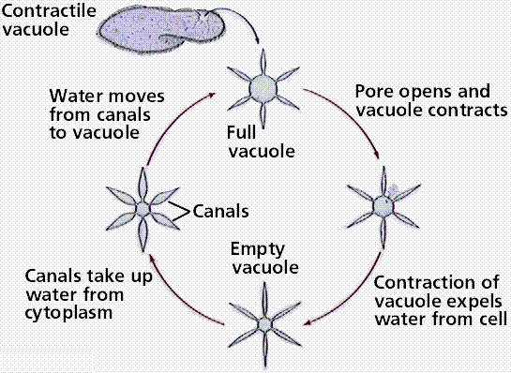

Hydra -It lives in freshwater. Unlike other species, the hydra lives in isolation. It has a maximum height of 2.5 cm, it is a fixed animal, but can also move. It has a tube-shaped body at one end having a widened area as a air vent that clinches on the plants. At the other end (which is always more developed) it has the opening with the role of mouth and anus, called mouth opening, which is surrounded by 5-8 thin and retractile tentacles, provided on their surface with numerous cell.
It has no excretory and respiratory system. The food captured by the tentacles, then paralyzed with a fluid from the little thread that is found on the cells. Finally the food is transported by the tentacles in the mouth opening and reaches the digestive cavity. Undigested food residues are removed back through the mouth opening.
