First day
First activity: Groups are formed by the teacher on the bases of their previous academic scores. Then teacher will distributes the jumble words related to science concepts like reduction, oxidation, deforestation etc., and ask students to rearrange and present among other groups.
Second activity: teacher will ask students to write their dreams on the stripes and then students mix all the stripes of their groups. Then teacher ask each students to take one stripes of their group member and tell in front of the class.
Third activity: teacher will provide real objects like creams, shampoo bottle, toothpaste etc., and ask students to discuss important things written on the objects in the class.
Second day
Group activity: teacher will provides handouts having some questions of the content discussed in the class and ask students to discuss among themselves in the group until they will thorough with the cotet.
Third day
Group activity: teacher will distributes pictures of different type of cells and ask students to differentiate ad state the functions of each.
Fourth day
Teacher will provide a picture of heart and ask students to guess the different parts of it.
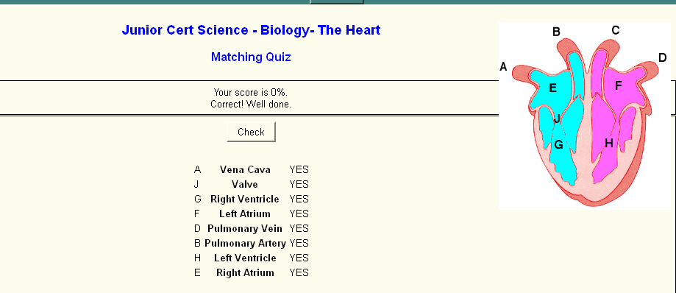

Fifth day
Teacher will provide pictures of transpiration of plants and ask students to write aim, observation and interference derived from the picture.
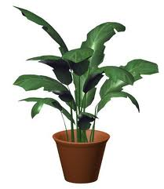
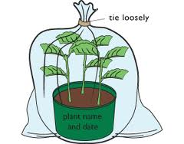
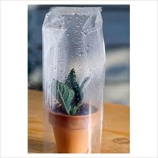

Sixth day
Teacher will provide cue cards having questions related to excretory system and ask students to do questioning in the groups until all the students give right answer.
Seventh day
Teacher will take post test of 25 marks and also take feedback from the students.

